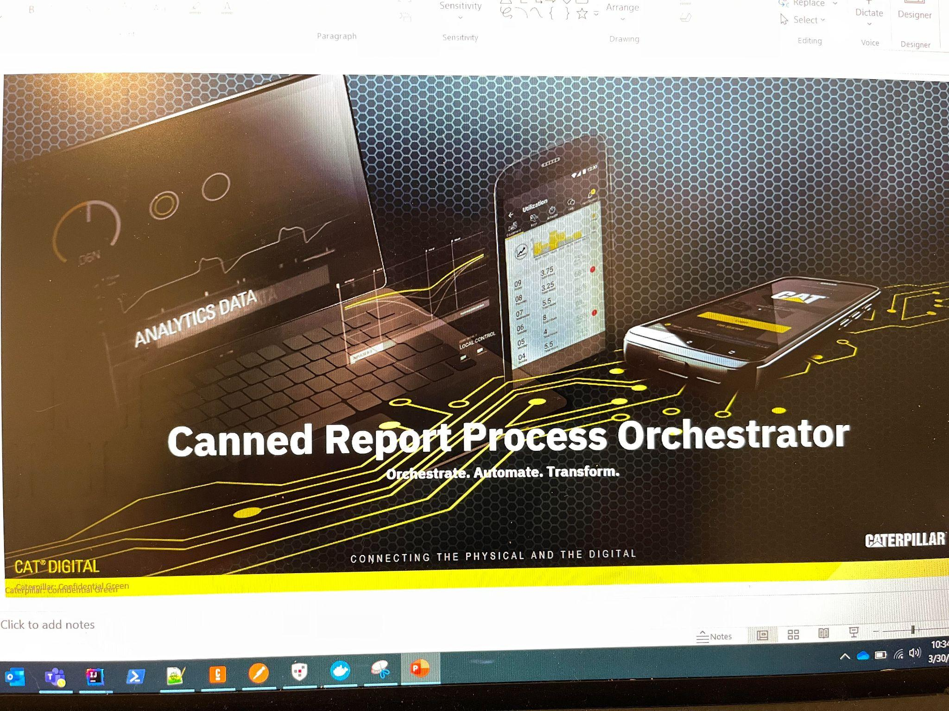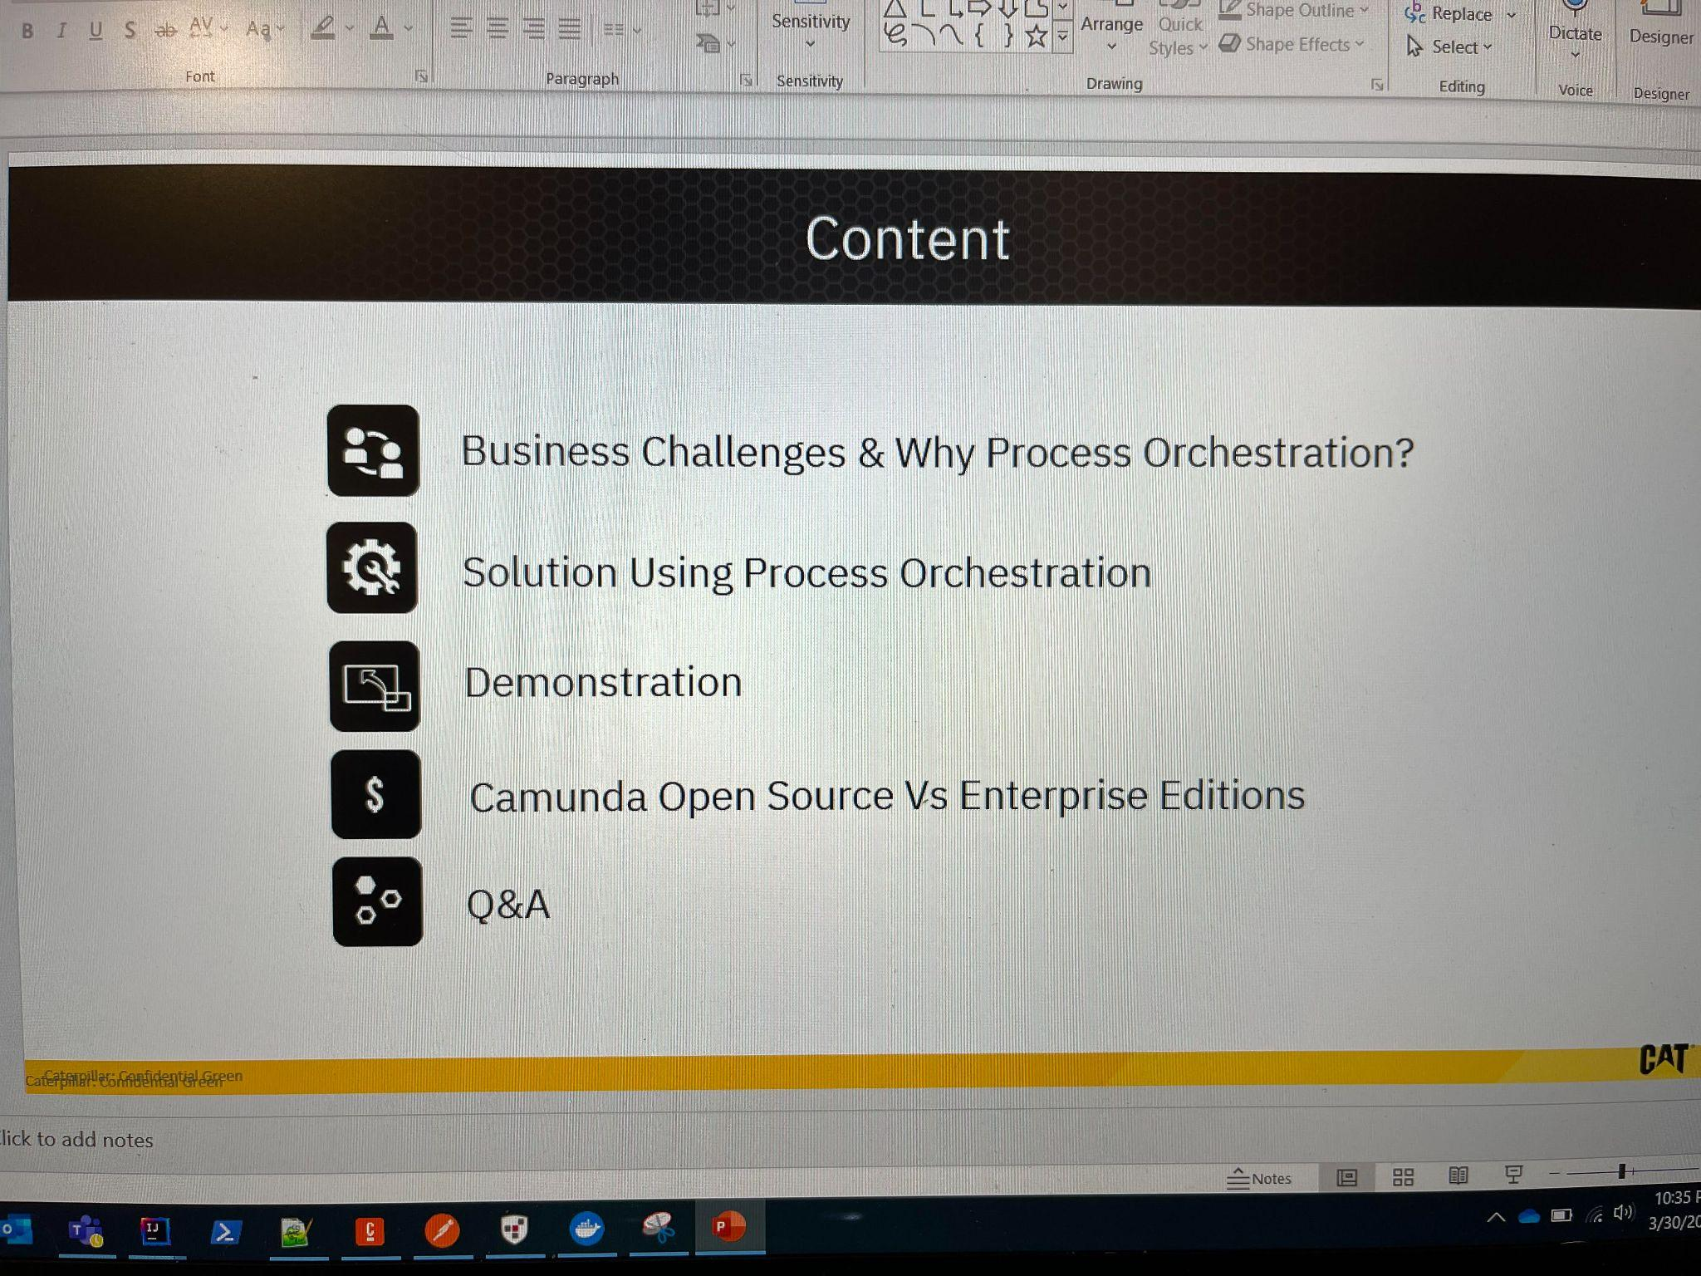

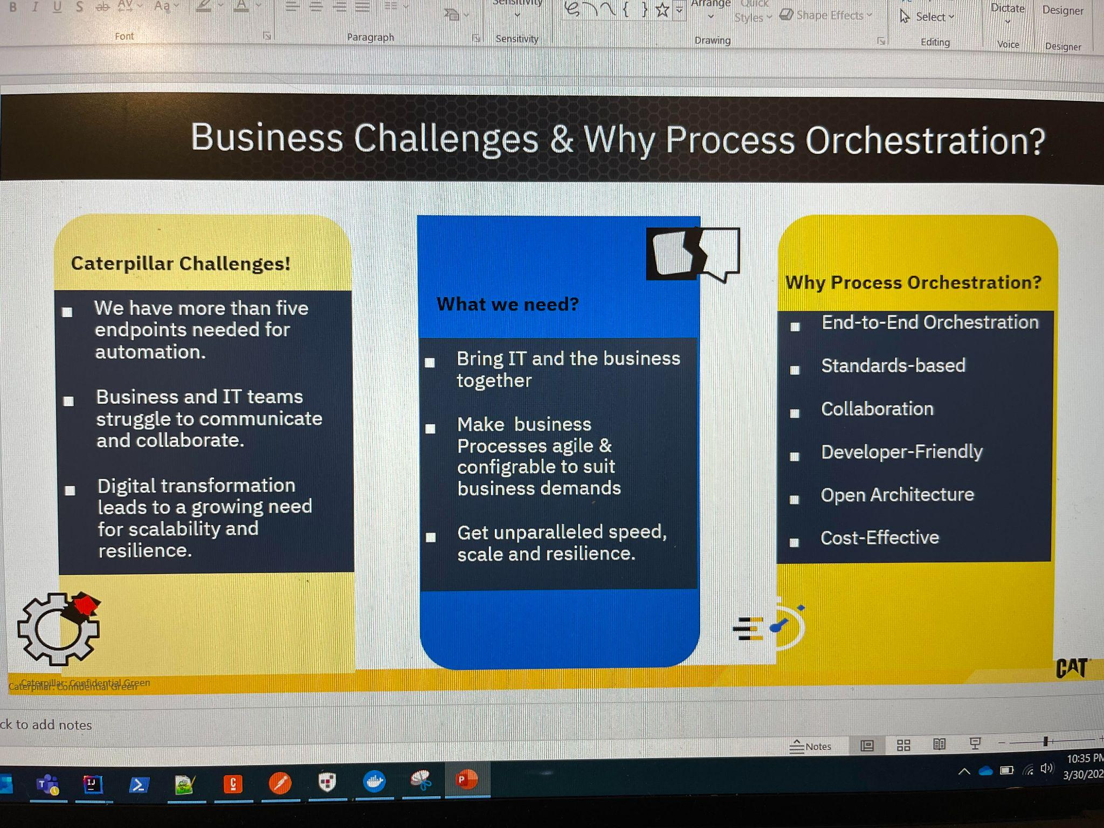

- For generating the canned reports, the process involves more than one end point for getting the report data,
  - Fault code Report
  - Fleet Usage Report
  - Asset Usage Single Asset Report

- IT can develop configurable workflows (BPMN/DMN) and business can change and implement based on the dynamic needs of the business by drag and drop.

- Organizations like us need to build the solutions/reports in quick time and CAMUNDA can help building more reusable components which can significantly reduce the effort.

- Technical explanation of the last Box.

Need Common language – standards

End to End Orchestration:
Complex process, flows across diversified endpoints (people, systems and devices)
Open Architecture:
Easily integrate with most common technical architectures and frameworks (Kafka, )
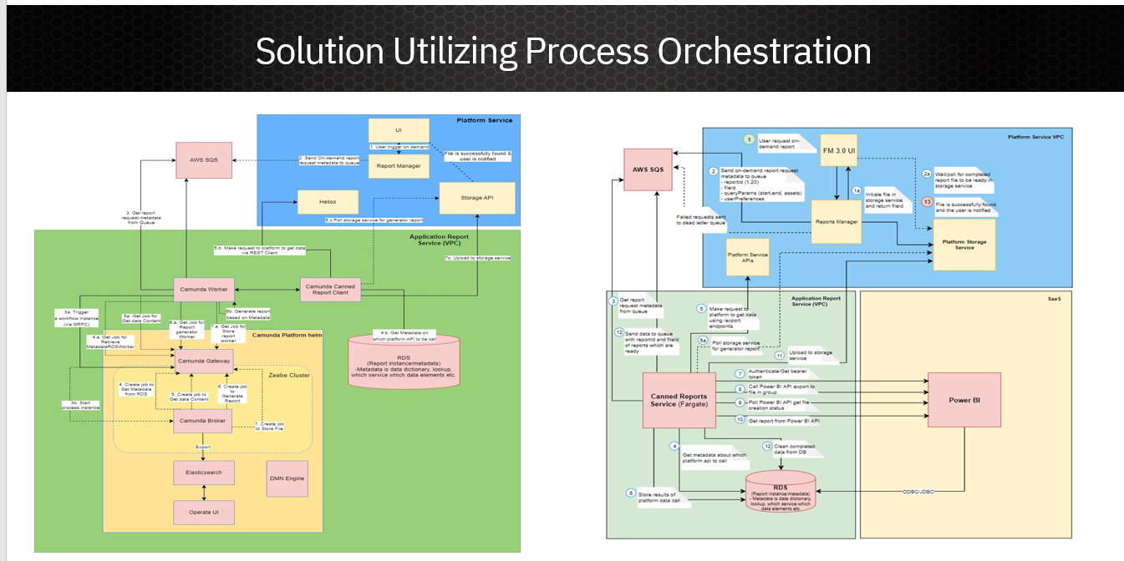

- Camunda Platform (Helm)
- Today the solution is consuming the SQS messaging using AWS Lambda, and the plan is to build “AWS SQS Inbound Connector” (Note: In-development)
- DMN: A rule engine as a service (Response, Merge and Filter Attributes; Endpoint URL; and Template Configuration)

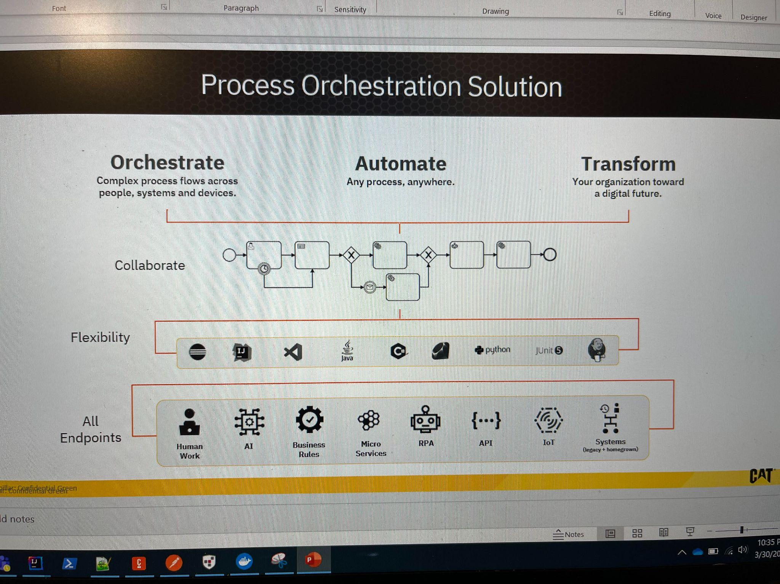

- Camunda will help orchestrate, automate and transform any business process.
- Camunda process flows will help collaborate with different departments within
- the organization
  - Ex: connects with SLACK, teams and can in corporate human tasks as part of the process flows.
- The business logic can be developed in any languages (java, python etc.) supported by GRPC protocols.
- Connect with any endpoints.

Collaborate:

- IT can develop configurable workflows (BPMN/DMN) and business can change and implement based on the dynamic needs of the business by drag and drop.

Transform:
- Organizations like us need to build the solutions/reports in quick time and CAMUNDA can help building more reusable components which can significantly reduce the effort.

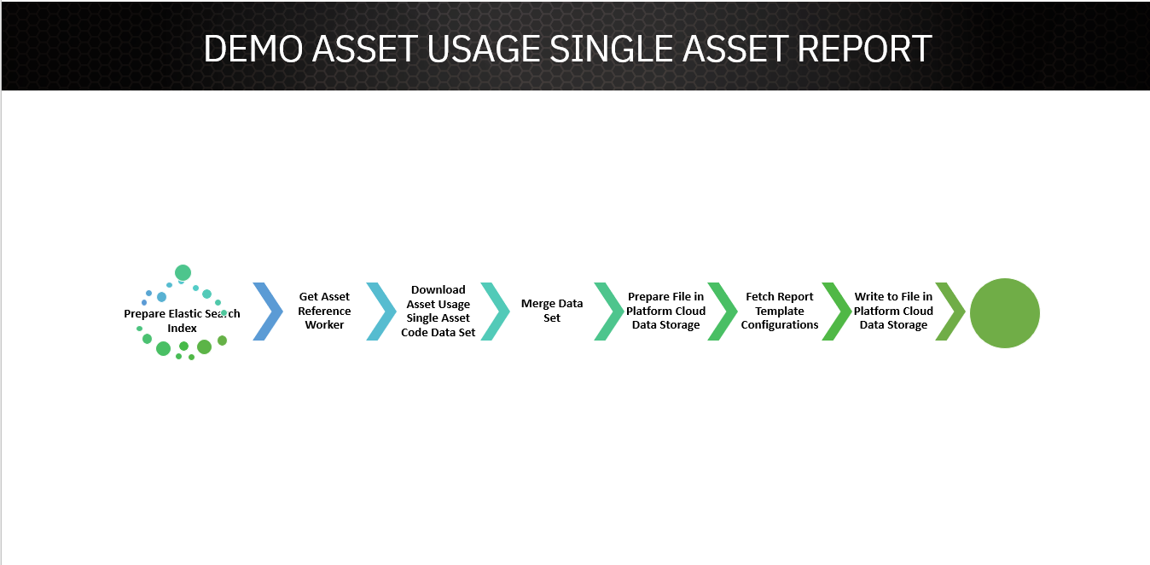

- Why elastic search? The data of the report is huge and cannot be stored in the running instance of the process
- Number of integrations – Asset Utilization, Asset
- Data aggregation
- Business rules will help configure Report templates & required attributes.

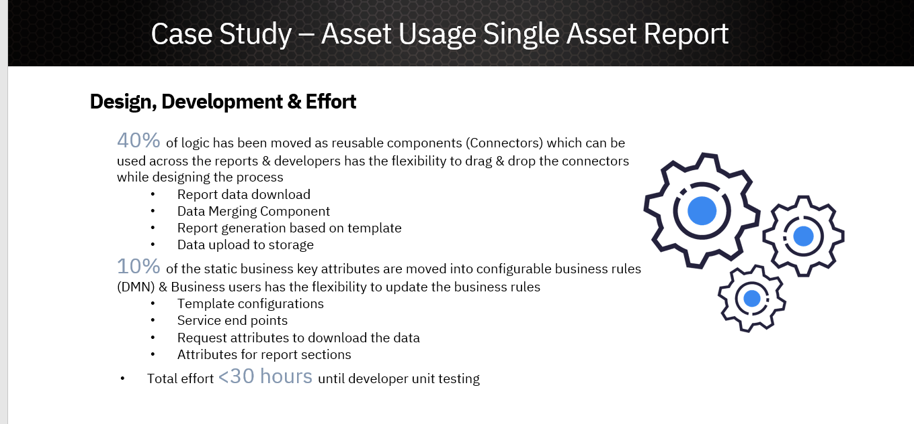

On average we developed a report less than 30 hours.

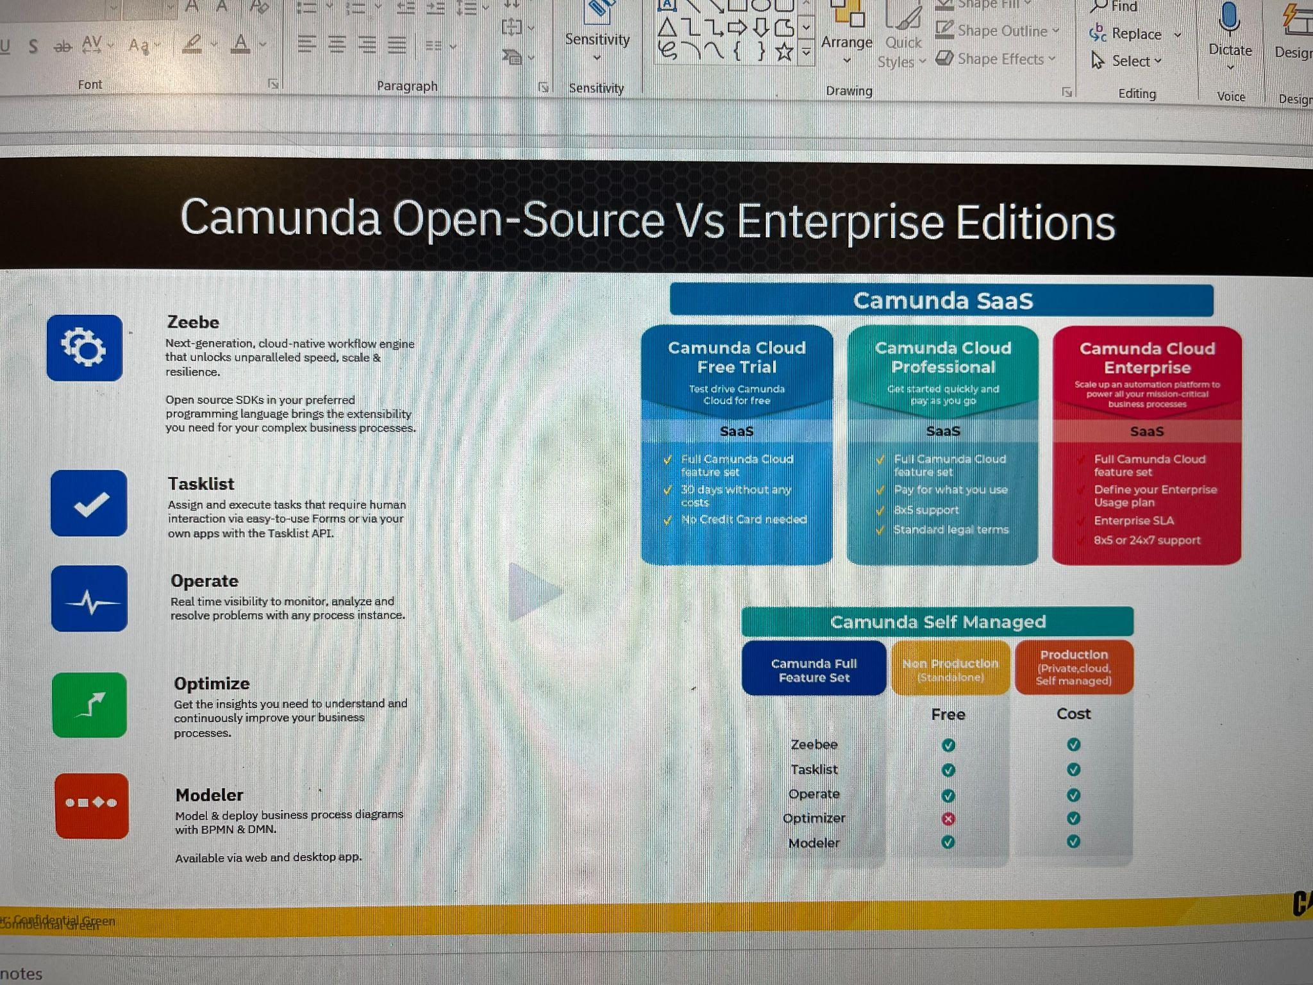

Camunda 8 Platform is package of components.
Zeebe – Core horizontally scalable workflow engine
Tasklist – Inbuilt application provided camunda for Human Task Orchestration
Operate – Monitoring tool to monitor the state of the workflow and analyze the incidents before resolving
Optimizer – Optimize offers business intelligence tooling for Camunda customers. By leveraging data collected during process execution, users can collaboratively access reports, share process intelligence, analyze bottlenecks, and examine areas in business processes for improvement.
Modeler (Desktop/Web) – For designing, deploying, Running the workflow.

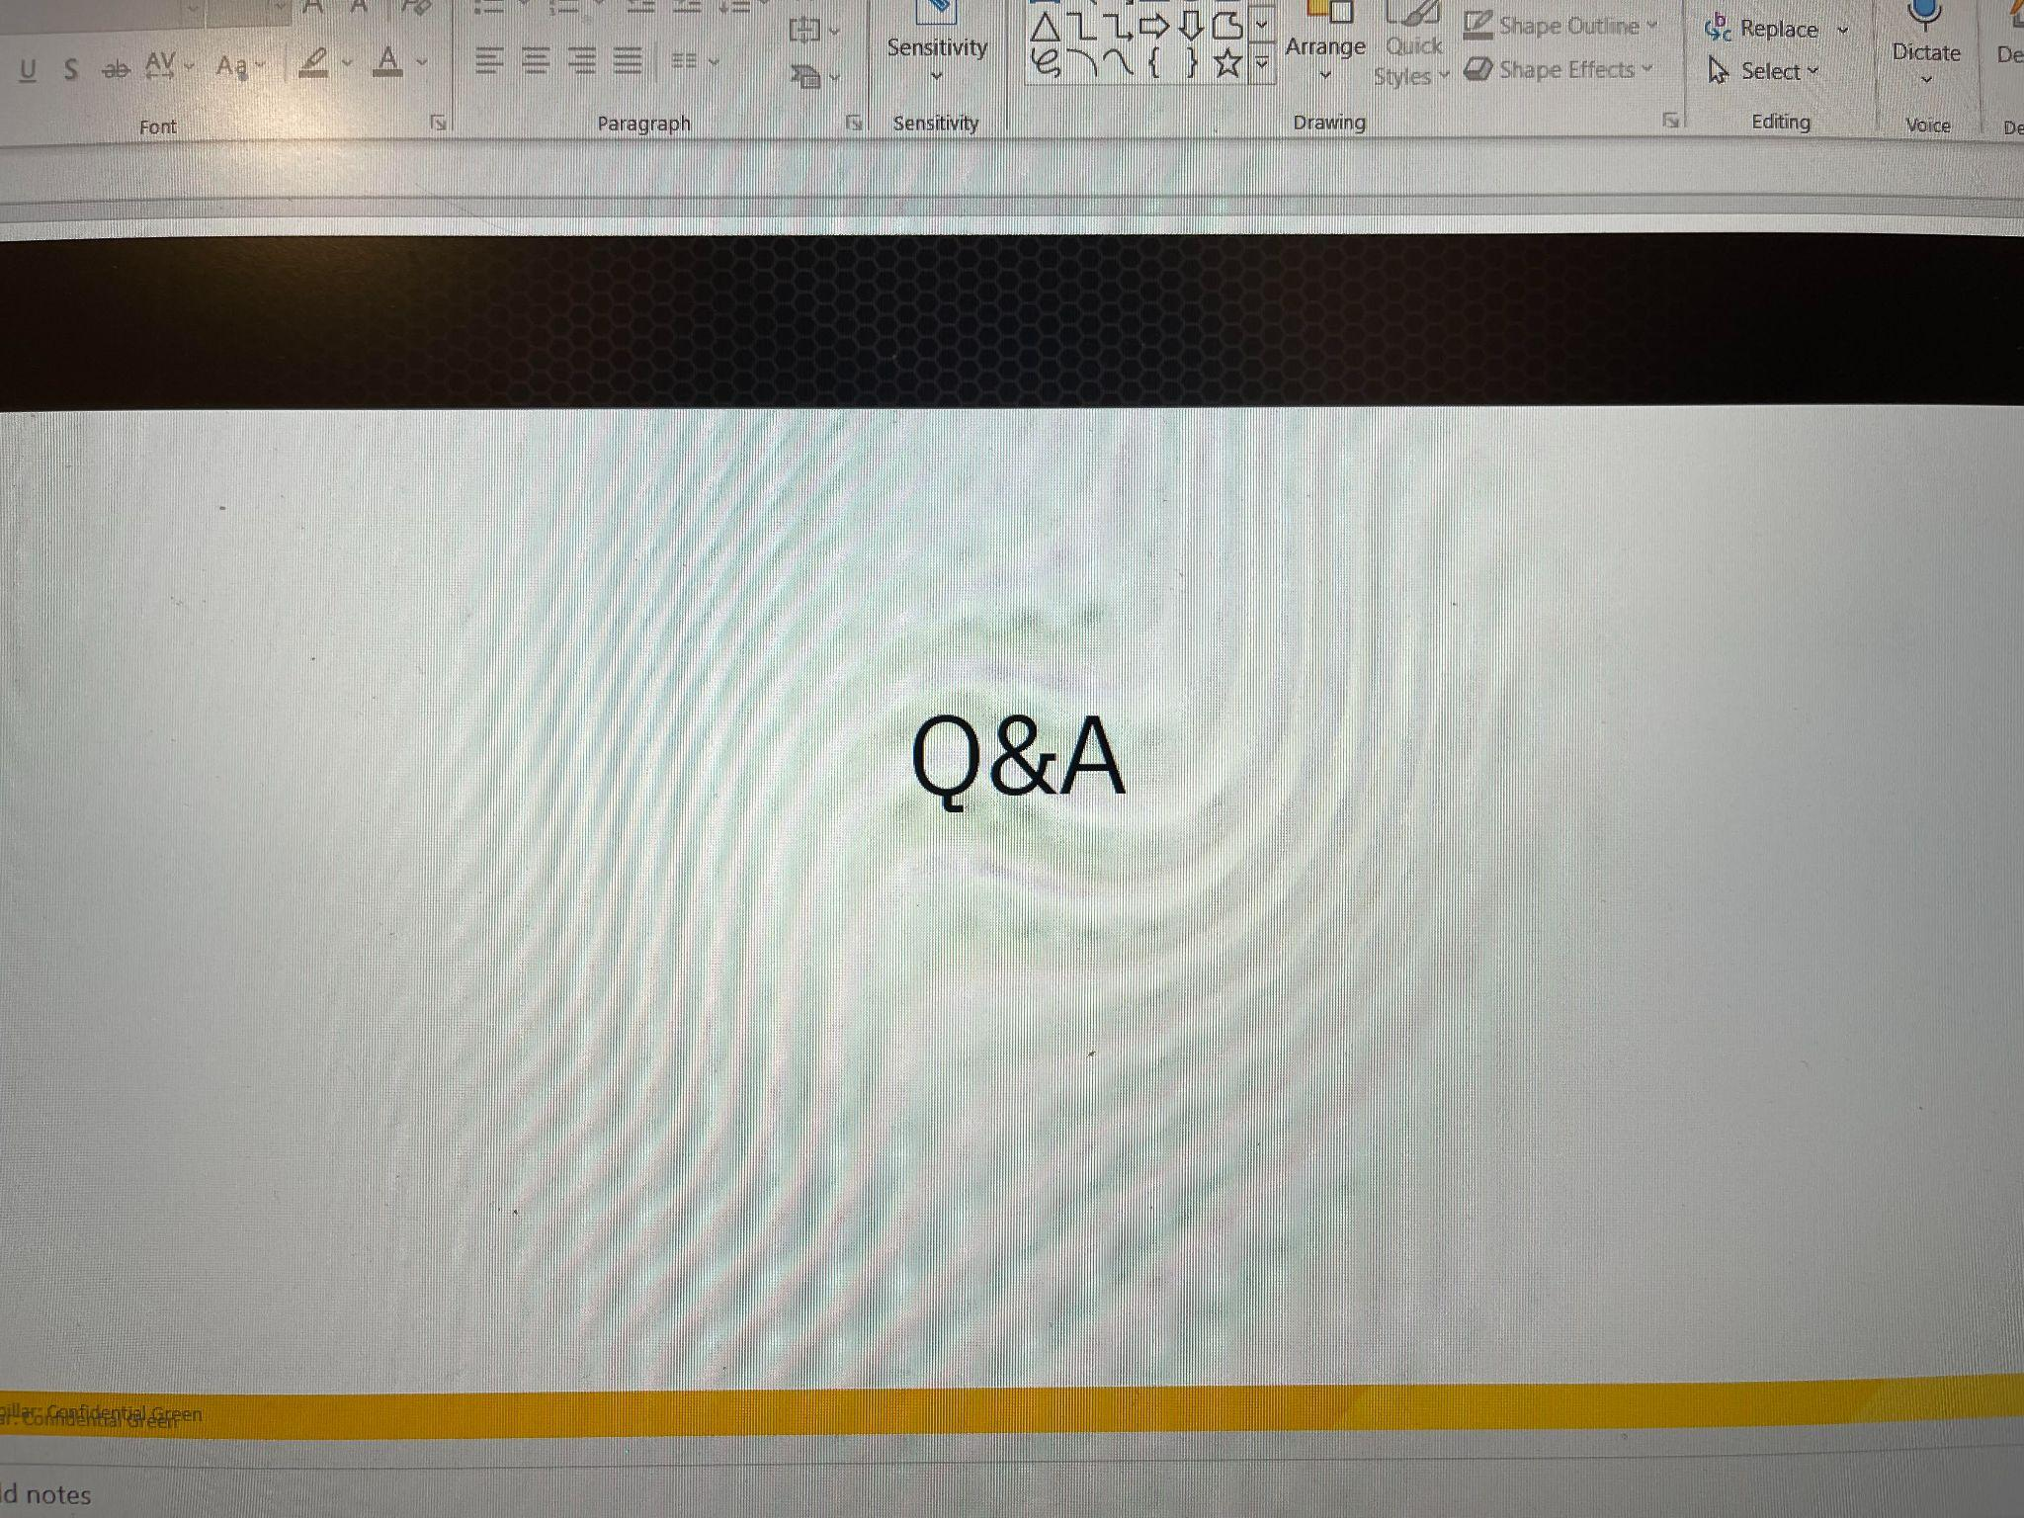

Supporting Slides:

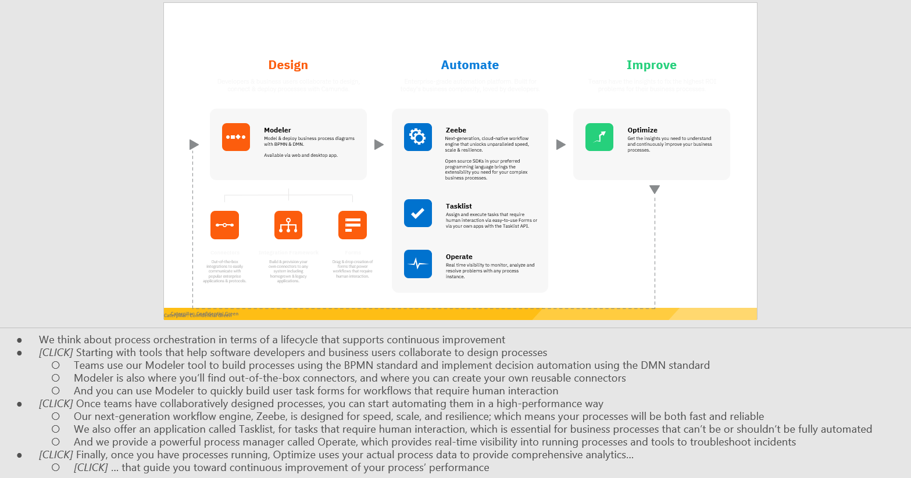

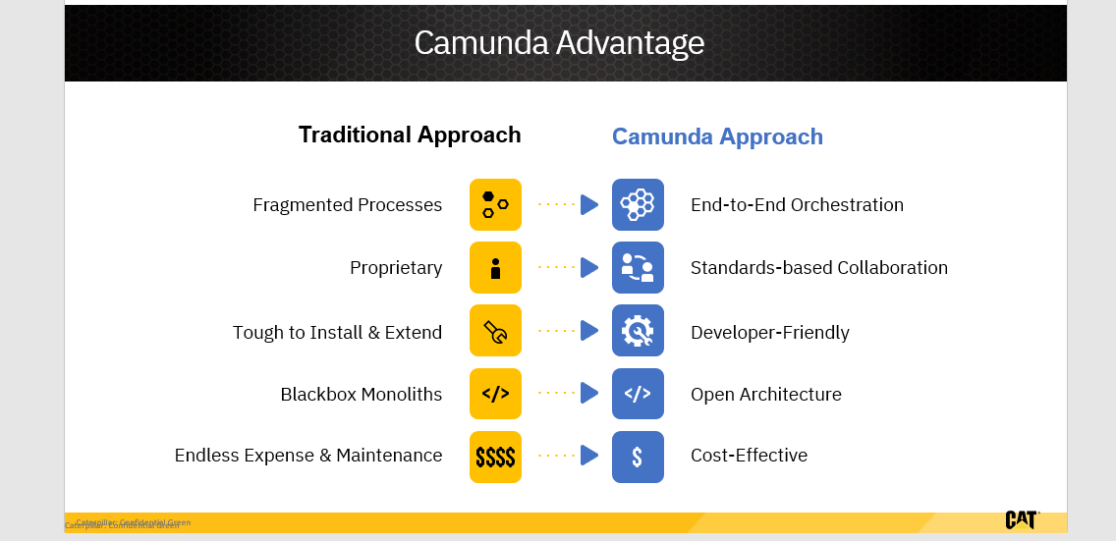

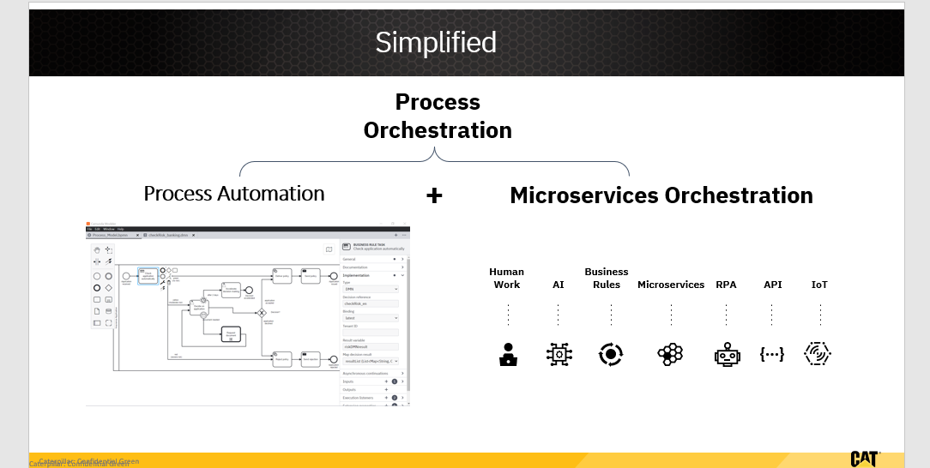

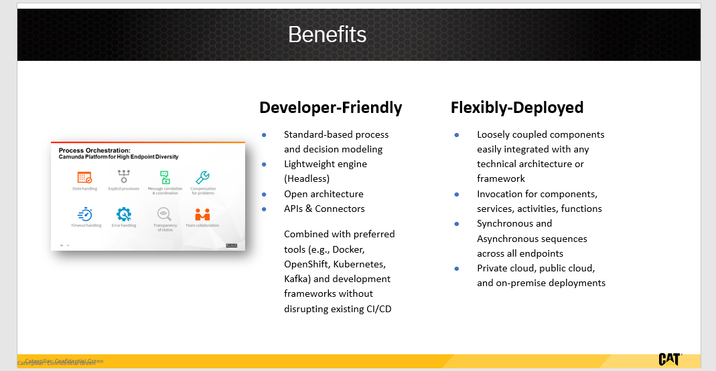

Optimize:

Benchmark
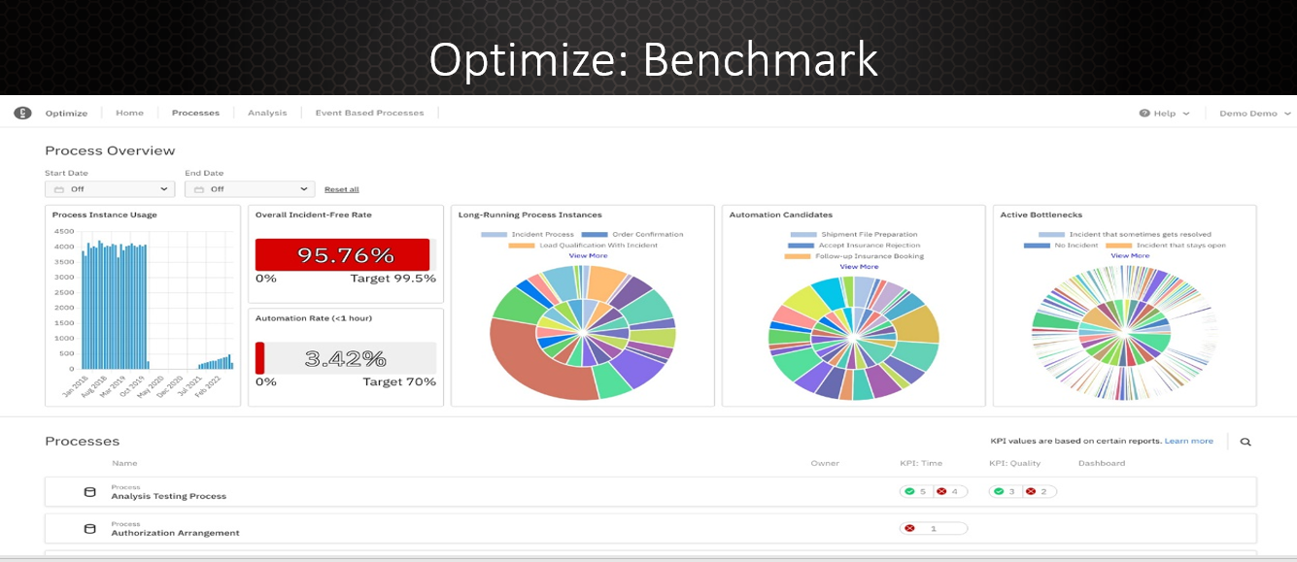

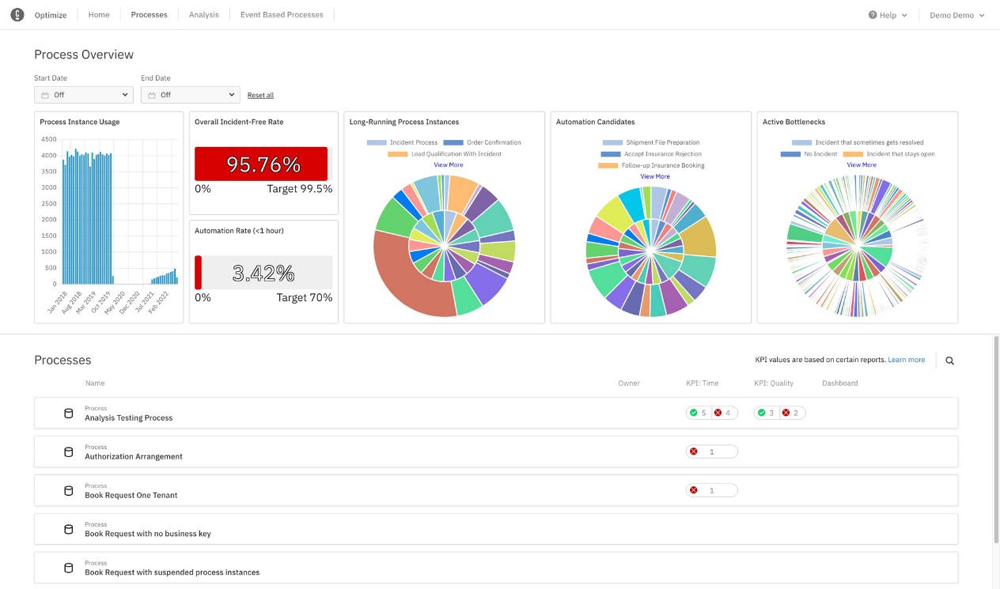

Monitor: Heat Map
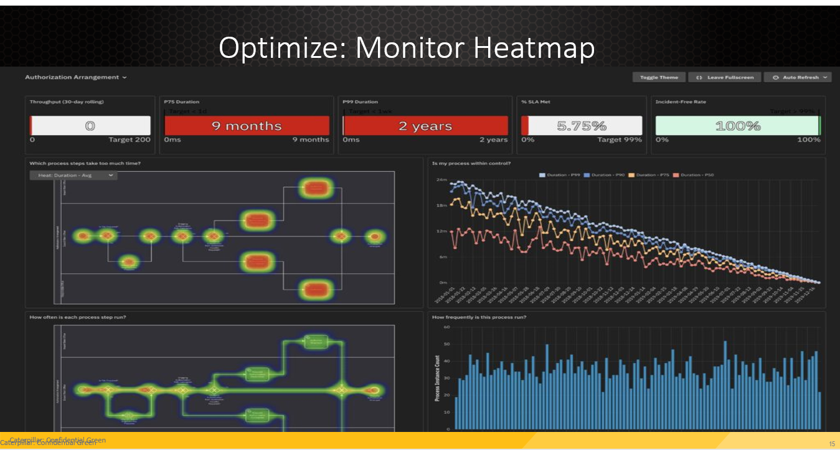
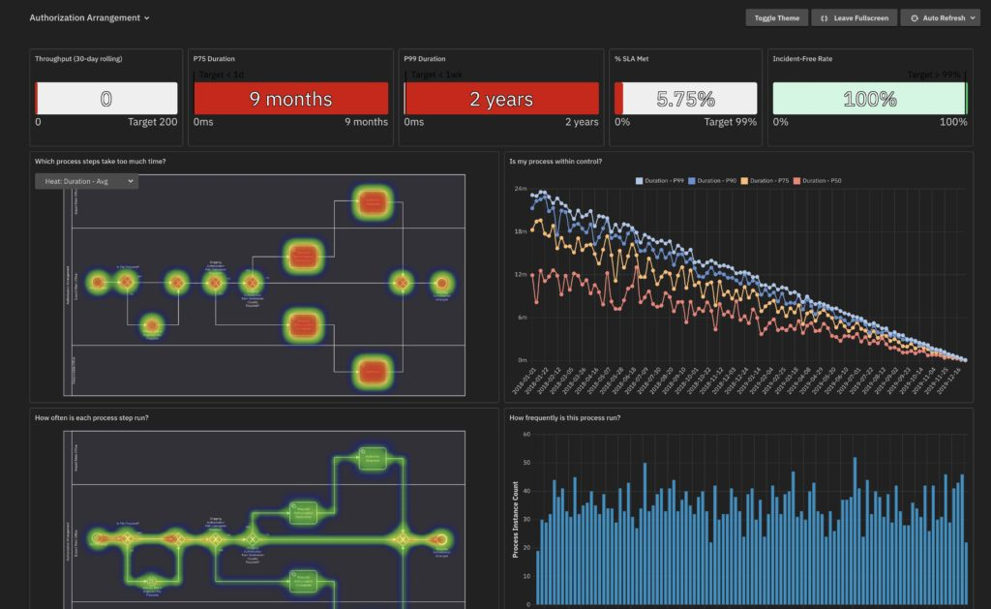

Analyze:
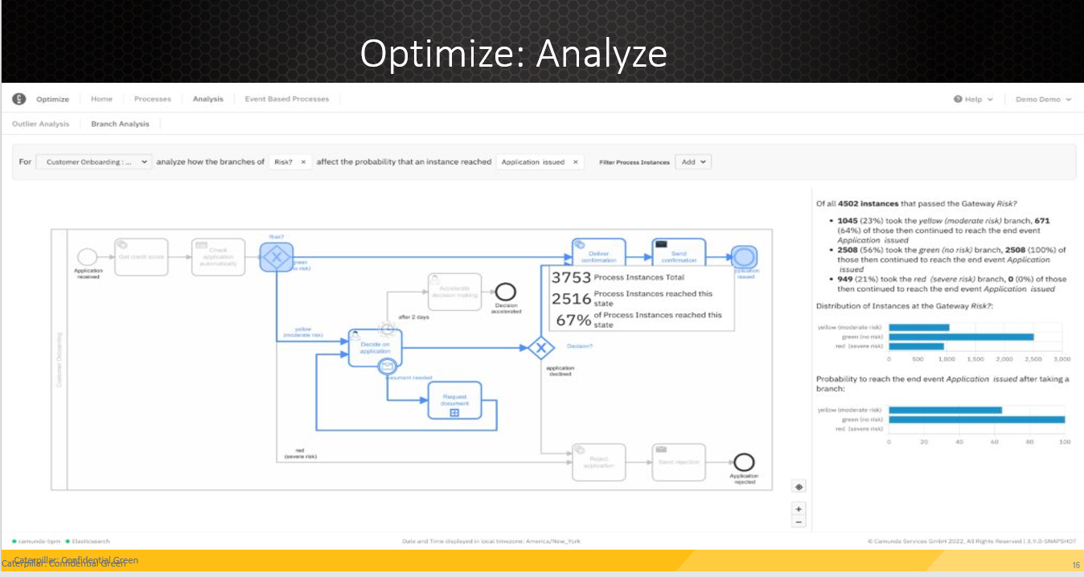

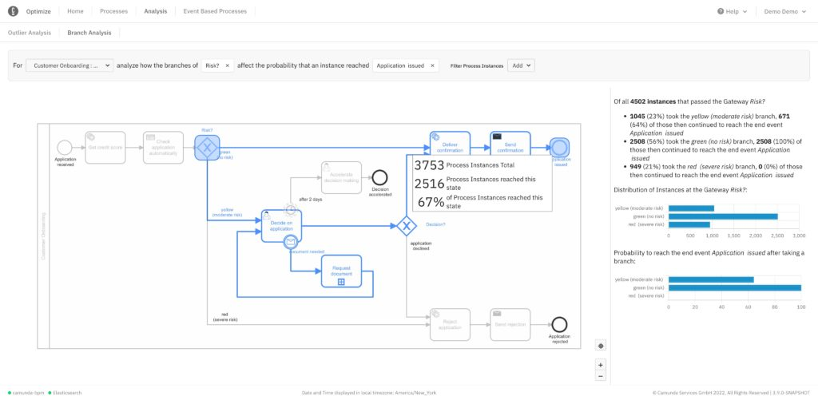

Evaluate:
